PROTECTION AND PERMANENCY TRANSMITTAL LETTER, 15-16

TO: Service Region Administrators
Service Region Administrator Associates
Service Region Clinical Associates
Regional Program Specialists
Family Services Office Supervisors

FROM: Tina Webb, Assistant Director
Division of Protection and Permanency

DATE: December 2, 2015

SUBJECT: New Format for APS and CPS Acceptance Criteria

This transmittal letter contains information regarding revisions to both child protective services (CPS) and adult protective services (APS) acceptance criteria. Technical assistance has been provided, in the form of face to face instruction, to all individual centralized intake (CI) teams.

In addition to the revised SOP, a new resource tool, Acceptance Criteria: Physical Injury and Assault in Children 4 and Younger, has also been posted to the SOP site. The tool was developed jointly between central office staff and Dr. Currie, Director of the Division of Pediatric Forensic Medicine at the University of Louisville. The tool categorizes specific injuries to children ages four (4) and younger, which according to national NCANDS data, and supported by Kentucky’s data, is the most common age for fatalities and near fatalities. The tool was developed by using actual cases and research regarding different types of physical abuse, specific to children four and younger.

In addition to the new resource tool discussed above, the following SOP sections and documents have also been revised or added to the manual:
- SOP 2.3 Acceptance Criteria and Reports that do not Meet (New format and renamed);
- SOP 19.3 Acceptance Criteria and Reports that do not Meet (New format and renamed)
- CPS Intake Checklist Template 1 (New);
- CPS Intake Checklist Template 2 (New);
- CPS Intake Checklist Template for Neonatal Abstinence Syndrome (NAS) (New);
- CPS Centralized Intake Examples and Answers (New);
- APS Centralized Intake Examples and Answers (New);
- FAQ for CPS Acceptance Criteria (New);
- FAQ for APS Acceptance Criteria (New);
- Path Selection and Movement to the Ongoing Function (New); and
- Case Naming Protocol Tip Sheet.
The following SOP sections have been merged with the newly formatted acceptance criteria sections for APS and CPS and will be deleted as individual sections:
- 2.5 Reports that are not Accepted;
- 19.3.1 Adult Physical or Sexual Abuse;
- 19.3.2 Adult Mental Injury;
- 19.3.3 Adult Self Neglect;
- 19.3.4 Caretaker Neglect;
- 19.3.5 Adult Exploitation;
- 19.3.6 Spouse/Partner Physical and Sexual Abuse;
- 19.3.7 Spouse/Partner Abuse Mental Injury;
- 19.3.8 Spouse/Partner Neglect; and
- 19.5 Criteria for Reports that are not Accepted.

Additionally, a new value has been added to the list of “Role/Relationship to the Victim” on the Reporting Source/Collateral intake screen in i-twist, and to the same list on the Reporting Source screen on the web referral, to assist staff in tracking referrals from family accountability, intervention and response (FAIR) teams. Referrals from FAIR teams must be tracked and counted in order to accurately capture information regarding how many referrals the agency receives from this group. However, reports from FAIR teams are screened using the same criteria as any other report. See the screen shots below:

i-twist:
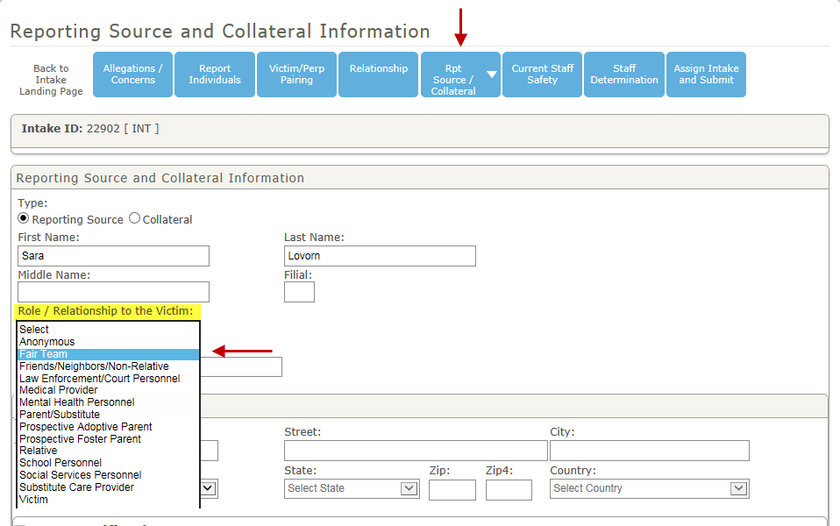

Web referral:
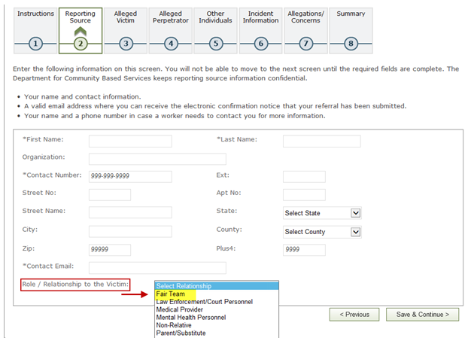

If you have any questions regarding this memorandum, please contact:

Lucie Estill, Child Protective Services Branch Manager
Lucie.estill@ky.gov
(502) 564-2136, ext. 3568

Steven Fisher, Adult Protective Services Branch Manager
Steven.fisher@ky.gov
(502) 564-7043, ext. 3570

